Asset inspection | MSP-01
Maintenance System Procedure | MSP-01
This document sets out procedures for inspecting the Asset to identify hazards and defects in a timely manner and to ensure compliance with Intervention Guidelines outlined in TfNSW Specification M3. It sets out the role of the Maintenance Inspector and describes the inspection system and how defects are identified and recorded using the Reflect system.

The Maintenance Inspector’s role
The Maintenance Inspector role is carried out by personnel who are trained and experienced in asset inspection.
- The Maintenance Inspector inspects the network to identify defects, and:
  - enters identified defects into the Reflect system
  - monitors the condition of assets and determines when routine maintenance intervention is likely to be required
  - records the accomplishment of the inspection.
- Inspections are conducted from a vehicle or on foot.
- Inspections are conducted at the frequencies set out in the Inspection Schedule and also in response to complaints, requests and Principal notifications.
The Maintenance Inspector notifies the TfNSW Coordinator of any defects that pose an immediate safety threat to the travelling public or could cause environmental harm. The Maintenance Inspector may rectify defects on the spot if it is safe to do so.
Defects are entered into Reflect. The exception is defects that can be rectified on the same day they are identified.

Reactive Roadside Maintenance
- Reactive maintenance is a category of maintenance that includes repair of safety related defects and repair of other defects needing a short response time. The requirements for reactive maintenance are described in detail in M3.Section 4.
- Reactive roadside maintenance (Activity 303) defects include but are not limited to: boundary fences, damage to noise walls, non functioning environmental measures within stockpile sites, removing a tree, overhanging branches or broken tree limbs in danger of falling onto travelled path.
- Reactive Bridge and Tunnel maintenance (Activity 701) defects are to be recorded with the information passed to Bridge Assets/Bridge Services for rectification. Defects are to be recorded for structures that are not functional or are damaged. An example is: damaged guardrail or missing reflectors.

Asset Inspection System
Council uses the Reflect system to manage the information requirements of maintenance delivery. This fulfils the requirements of Specification M3 Section 3.1 Asset Inspection Requirements.
Reflect is used to create inspection schedules and calendars and produce defect registers. The system is also used to track compliance with inspection and defect rectification requirements. Inspections are made traceable through a unique inspection number generated when the Inspection Calendar is created in Reflect. Maintenance Inspectors verify that inspections have been done through the Inspection Schedule and Calendar (which tracks planned versus actual inspections).
The identified defects data in Reflect is used to generate a work schedule (refer MSP-04 Work Scheduling).

Asset Inspection Calendar
The inspection schedule is set up in Reflect at the start of each project year (financial year). The Reflect system produces an Inspection Calendar covering a minimum period of twelve months.
The Inspection Calendar is based on the inspection frequency table in Specification M3 Section 5.1 Frequency of Inspections.
An Inspection Number is allocated for each length of road to be inspected.
The inspections are noted as ‘complete’ on the Inspection Calendar Report in Reflect once they are done.

Recording accomplishment
The Accomplishment of asset inspections is recorded in the Inspection module, or the Accomplishment module Card View. The accomplishment record must include the Inspection Number with the date of inspection to confirm that the inspection was completed. Each accomplishment is corresponding to each length of road inspected.
Maintenance Inspectors must synchronise their Reflect database with the central database daily at the start and the end of the shift. This ensures that maintenance data on the computers and centralised database is no more than one shift old.
Maintenance Inspectors must not delete records from Reflect. If a record must be deleted, it can only be deleted by the Reflect Officer.

Defect identification
Defect identification must be in accordance with TfNSW Specification M3 covering Intervention Standards for Reactive Maintenance defects and Intervention Guidelines for Routine Maintenance defects.
The Maintenance Inspector monitors the existing defects for deterioration and amends the description and priority in Reflect, if required.
If the Maintenance Inspector finds that a defect has been rectified on site, without an Accomplishment record, then the defect is to be closed out by the Maintenance Inspector. Instances of rectification without defect close-out must be reported to the Project Officer.
Closing defects without accomplishment must include a brief comment stating the reason and who is authorising the close, to ensure there is a clear audit trail.

Defect prioritising and status
Defects identified are to be prioritised to meet the requirements of TfNSW Specification M3 Section 3.4.
The defects that the Maintenance Inspector identifies are to be recorded with the mandatory field “Priority”. The defect is to be allocated the priority, chosen from the drop down lists as in the Priority Table MSP01.1 below. The response time determined by the Maintenance Inspector is a guide for the scheduling of work to rectify the defect. The Project Officer and the Technical Officer will determine the work scheduling to rectify the defect.
The Priority rating is based on risk assessment principles of the severity of the defect and the likelihood of it progressing beyond the Intervention Guidelines for the defect.
The Priority rating is outlined with the corresponding “Guide to response time” in Table MSP01.1
Priority Table – MSP01.1
Priority | Description | Guide to response time
1 | Urgent | Rectify within 1 week
2 | High | Rectify within 2 weeks
3 | Medium | Rectify within 1 month
4 | Low | Rectify within 6 months
5 | Monitor | May take more than 12 months to rectify
HP | Heavy Patch pavement defect >20m²
The Defect Status is additional information that also may be recorded as outlined in the Table MSP01.2.
Defect Status Table – MSP01.2
Defect Status | Status Description
• Defer | Await further instructions - Monitor
• Monitor | Monitor for further signs of deterioration

Defect identification – pinning defects in Reflect
All defects identified in an inspection, are pinned using the Reflect Defect module, Map View. The Inspector must take care to zoom the map to a level where the defect can be accurately pinned on the correct carriageway or corridor area.
Pinning a defect is not required when it is guaranteed that a work team will rectify the defect on the same day as it is identified. This prevents a mismatch between the defect and accomplishment in the Reflect database from the data being out of synchronisation.
Defects are generally recorded as individual isolated defects. However, if there are many instances of the same defect found over a short section of road, they can be recorded as a group.

Rules for pinning specific defects

Defect | Rules for pinning defects
Potholes (Act 201) | Pothole defects can be pinned as a group if they are close together. For example, a 100 metre length of lane carriageway with two or more potholes only needs to be pinned once. Grouped pothole defects must be within a segment.
Non-pavement delineation (Act 611) | Guidepost defects can be pinned as a group within a segment. However, consider pinning them individually or as smaller groups if it will help the work team to locate the defect.
Control Ground Vegetation (Act 311) | Pin a defect when non-programmed spraying, mowing and slashing is required. Examples include hazardous defects, or when a specific inspection identifies a weed outbreak or a sight-distance hazard.

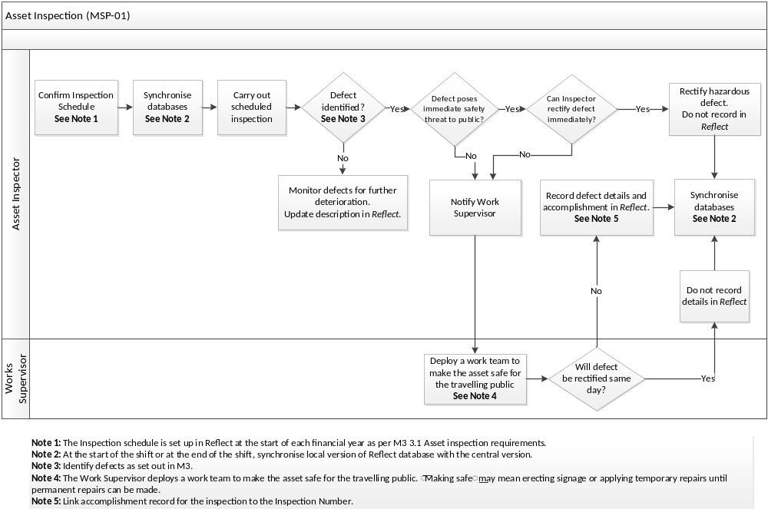
Works Overseer

Maintenance Inspector (Road Project Officer)

